**A Project Report**

**On**

**OPERATIONS MANAGEMENT**

*Submitted to*

**JAWAHARLAL NEHRU TECHNOLOGICAL UNIVERSITY ANANTAPUR,**

**ANANTHAPURAMU**

*In Partial Fulfillment of the Requirements for the Award of the Degree of*

**BACHELOR OF TECHNOLOGY**

**In**

**ELECTRONICS & COMMUNICATION ENGINEERING**

**Submitted By**

1. **BALAJI - (16691A04C1)**

**Under the Guidance of**

**Dr. SUMIT GUPTA, Ph.D.**

**Senior Assistant Professor**

**Department of Electronics & Communication Engineering**



**MADANAPALLE INSTITUTE OF TECHNOLOGY & SCIENCE**

**(UGC – AUTONOMOUS)**

**(Affiliated to JNTUA, Ananthapuramu)**

**Accredited by NBA, Approved by AICTE,New Delhi**

**AN ISO 9001:2008 Certified Institution**

**P. B. No: 14, Angallu, Madanapalle – 517325**

**2016-2020**



**DEPARTMENT OF**

**ELECTRONICS & COMMUNICATION ENGINEERING**

**BONAFIDE CERTIFICATE**

This is to certify that the project work entitled “**OPERATIONS MANAGEMENT”** is a bonafide work carried out by

**J. BALAJI - (16691A04C1)**

Submitted in partial fulfillment of the requirements for the award of degree **Bachelor of Technology** in the stream of **Electronics & Communication Engineering** in **Madanapalle Institute of Technology & Science,** Madanapalle**,** affiliated to

**Jawaharlal Nehru Technological University Anantapur, Ananthapuramu** during the academic year 2016-2020.

Guide Head of the Department

**Dr. SUMIT GUPTA ,P.hD. Dr.S.RAJASEKARAN, Ph.D,**

**Senior Assistant Professor Head of ECE Dept**

**Department of ECE Department of ECE**

Submitted for the University examination held on:

**Internal Examiner External Examiner**

**Date: Date:**

**ACKNOWLEDGEMENT**

I express my sincere and heartfelt gratitude to Dr. Sumit Gupta,Sr. AssistantProfessor in Dept. of E.C.E, M.I.T.S, Madanapalle who has guided me in completing the Project with his/her cooperation, valuable guidance and immense help in giving the project a shape and success. I am very much indebted to him/her for suggesting a challenging and interactive project and his valuable advice at every stage of this work.

We are extremely grateful to **Dr.S.Rajasekaran, Ph.D., Head** **of ECE** for his valuable guidance and constant encouragement given to us during this work.

We sincerely thank **Dr. C. Yuvaraj, M.E., Ph.D., Principal** for guiding and providing facilities for the successful completion of our project at **Madanapalle Institute of Technology & Science,** Madanapalle.

We sincerely thank the **MANAGEMENT** of **Madanapalle Institute of Technology & Science** for providing excellent infrastructure and lab facilities that helped me to complete this project.

We would like to say thanks to other **Faculty of ECE Department** and also to our friends and our parents for their help and cooperation during our project work.

**DECLARATION**

We hereby declare that the results embodied in this project **“OPERATIONS MANAGEMENT”** by us under the guidance of **Mr. Dr. SUMIT GUPTHA, M. Tech, Ph.D. Sr. Assistant Professor, Dept. of ECE** in partial fulfillment of the award of **Bachelor of Technology** in **Electronics and Communication Engineering, MITS, Madanapalle** from **Jawaharlal Nehru Technological University Anantapur, Ananthapuramu** and we have not submitted the same to any other University/institute for award of any other degree.

**Date :**

**Place :**

**PROJECTASSOCIATE**

**J.BALAJI - (16691A04C1)**

I certify that above statement made by the students is correct to the best of my knowledge.

**Date : Guide**

**ABSTRACT**

Business fields are developing day by day leading to different types of sales activities including enhancement of various technical and soft skills.The role we are about to take in the sales fields decides how it will change indvid- ual’s skills can be enhanced. Some of the positions includes sales manager, technical operator, game master etc., These field mainly depends on the communication ability with others especially strangers. The game master job is like addressing the customers and letting them to know what are all the availabilities in the center.

Engaging the customers in some phase of technical issues is the tedious task and later on setting up all the operators on then they need to be given briefing regarding the procedure how to play the game and giving them with the equipment and making them to play the game.

**INDEX**

|  |  |  |
| --- | --- | --- |
| S.NO | TOPIC | PAGE NO |
| 1 | INTRODCTION | 8 |
|  | 1.1 About Project | 8 |
| 2 | LITERATURE SURVEY | 9 |
|  | 2.1 Purpose of the Project | 9 |
|  | 2.2 Existing System | 9 |
|  | 2.2.1 Drawbacks of Existing System | 9 |
|  | 2.3 Proposed System | 10 |
|  | 2.3.1 Advantages of Proposed System | 10 |
| 3 | METHODOLOGY | 11 |
|  | 3.1Introduction | 11 |
|  | 3.2 Laser Tag | 11 |
|  | 3.3 Escape Rooms | 14 |
| 4 | HARDWARE DESCRIPTION | 19 |
|  | 4.1 Introduction | 19 |
|  | 4.2 Personal Computer | 19 |
|  | 4.3 Shields and Guns | 21 |
|  | 4.4 Inner View of Gun | 22 |
|  | 4.5 Screw Driver | 23 |
| 5 | SOFTWARE DESCRIPTION | 25 |
| 6 | CONCLUSION | 28 |

List Of Figures

|  |  |  |
| --- | --- | --- |
| S.NO | TITLE | PAGE NO. |
| 1 | 3.2.1 Laser Tag Flowchart | 13 |
| 2 | 3.3.1 Escape Room Flowchart | 18 |
| 3 | 4.2.1 Personal Computer | 20 |
| 4 | 4.3.2 Shields Connected with Guns | 22 |
| 5 | 4.4.1 Inside Circuitry of Gun | 23 |
| 6 | 4.5.1 Screw Driver | 24 |
| 7 | 5.1 Houdini MC Home Screen | 25 |
| 8 | 5.2 Timing Screen | 27 |

**CHAPTER 1**

INTRODUCTION

* 1. **About Project**

“Operations Management” can be done in many fields. There were lot many areas where these action plan can be implemented. Some among them includes gaming, marketing, etc.,

Our current project deals with operations management in gaming field. Here we can come come across various actions and different types of people. It mainly depends on gameaholic. Those who are passionate about playing physical games.

It is mainly an team or group event which comprises of minimum of 3 members and maximum of 8 to 12 members. Here we can able to find different types of processes to be involved like managing crowd, describing them about the game and making them to play the game and collection of cash for their experience at the end of the game.Here we can able to find friendly environment that enhances one’s ability to mingle with new people.

**CHAPTER 2**

LITERATURE SURVEY

**2.1 PURPOSE OF THE PROJECT**

The purpose of the project is to communicate different customers and allowing them to perform certain activity and to collecting money from them for their experience which leads us to gain some of the soft skills like developing communication skills, team building, team leading, public speaking etc.,

The main motive of this project is to communicate with customers directly and building healthy relations with them.

**2.2 Existing System**

People used to play online games in mobiles, laptops, personal computers, tablets which are offline and online mode as well.

These games can be in the form of apps which can be downloaded from app store and playstore.

These also played directly in the website itself without usage of any pre-loaded applications.

2.2.1 Drawbacks of Existing System

Some of the issues related with these systems are explained as:

1. Eyes will get affected easily due to continuo-

ous aiming of eyes at particular gaming screen and its whitelight.

1. Stress will be applied on the mind that leads to infection of nerves.
2. Continuous gaming causes eye-sight.
3. System gets slower ultimately damaging the it’s parts.

**2.3 Proposed System**

Some of the drawbacks of existing system were explained above and those should be

It is the process of playing games physically where all the parts of the body will be given with some work. It allows customer to involve in real time activity of gaming.

2.3.1 Advantages of Proposed System

1)It provides physical fitness to the user and

keeps mind relaxed.

1. Develops healthy bonding with each other.
2. Makes mind to be refreshed removing mental

strain.

1. Helps in understanding others capabilities

Apart from our own abilities.

1. Brings out innovative skills out from mind.

**CHAPTER 3**

METHODOLOGY

**3.1 Introduction**

The project operations management deals mainly with two types of gaming activities like LASER TAG and ESCAPE ROOMS.

These are the two types of games that our organization offers under this project. What actually the Laser tag is that the group of peoples will be allowed to play a particular game in a closed environment with specific environment wearing on their bodies.

**3.2 Laser Tag**

Let’s coming to deep in the game **Laser Tag**, it is a shooting game inside the closed room called ARENA with shields wearing on them which comprises of a Gun, sensor parts indicated with blue, red colored LEDs.

The main motive of this game is to shoot each other or to shoot opponent teammates which in-turn leads to scoring of points. Sensors were placed at different positions of the body shields.Different sensors carries different points just like front part consists of 100 points, back,it will be 80points, shoulder sensors carries 60 points, Gun face carries 40 points.

The motto is to aim the opponents at these many different places and hit them which releases laser beam of light and if it hits exactly at those sensors, then the score will be keep on added depending on the position of hitting.

Inside the Arena there will be lot many un-identically shaped walls which helps us to hide ourselves so as to safeguard ourselves from shooters. Once we were caught by someone then the gun will be deactivated for 5seconds. During this deactivation time gap we need to search for better place that is suitable for safeguarding our shields and guns.

Generally the game lasts for minimum time period of 12minutes and maximum up-to 24 minutes. The duration of the game depends on the interest of individual. Initially as soon as the customer walks into the center they should be greeted and need to inform them about the different games and their pricing.

After selection of particular game, let’s say laser tag then we need to hand over them the body shields to wear on their bodies. We also explain them the procedure how to handle the equipment and game plan as well. We also need to tell them some of the safety measures so as to safeguard the equipment and their health also.

Some of the measures include:

1. Should not run.
2. Should not crawl.
3. No physical contact is entertained.
4. Climbing the walls also not accepted.

The flow of Laser Tag game goes as below:

Customer

entry

Selection

Of

Laser Tag

Play the

Game and return

Equipment

wearing

Entry to

The arena

giving

Send off

Payment and

refreshments

Fig 3.2.1:laser tag

flowchart

**3.3 Escape Rooms**

Getting deep into the description about the game escape rooms let’s know what actually it means- “*It is a physical adventurous game which is a theme based which lasts upto an hour in which we could the hero of our own story and need to solve various riddles and crack codes which ultimately leads to get out from the particular locked room*”.

For this game the setup includes a closed room designed as per the theme and various kinds locks such as number locks, Alphabetical locks, directional locks, alpha-numerical locks.

This game doesn’t include any kind of score, only thing is to solve the puzzles and find various codes for various locks inside the locked room and make use of them to come out of that particular room.

The game Escape Rooms in our center gamingalaxy includes five different themes like:

1. Pirates Prison Heist
2. Ghost Writer
3. Chakravyuh
4. Hijacked
5. Time Machine

Each different theme is based on different story. Depending on the story the room design was done.

Like pirates depicts adventures and robbery the walls and the items in the room used to look like old and stolen items. In the same way Ghost writer being scary theme the walls were painted with scary devil images. Chakravyuh represents old age and the things tells epic stories. Time machine being advanced all the probs are highly, technologically enhanced. Finally Hijacked being related to airlines it seems like real airport.

Various themes are associated with various stories. In case of ghost writer there was an ghost inside a mansion and whomsoever enters the palace they will be locked permanently if at all they fail to escape from that place within an hour. There were lot many rumours saying the ghost used to sit on type writer and makes creepy sounds in the nights.

Coming to pirates prison heist, pirates of carribean sea used to kidnap the sea travellers in the nights and they were locked in their den and the clues to escape from that place were on the walls and probs in the den which need to be triggered out and should escape from that place.

Chakravyuh posses different sort of story saying that so as to join in the well named witchcraft university which is famous for magical tricks we need to qualify an entrance test in which we need to find five different chakras and place them in a particular manner in order to qualify the test.

Hijacked comprises the story as the culprits called terrorists have hijacked the aeroplane and turned off all the runways . Our task is to enter the place from back door and turn on the runways using secret button and make the planes to take off safely.

Time Machine holds a story of scientists have invented a machine which can go forward in time and backward as well. The aim that by looking all the disasters around us in future 2040 we need to go back to the past using the time machine and need to make some essential changes in the technological advancements and need to put an end to the disaster.

In this way different theme is comprised of different story.

Once the customers enters the room in which the game should be played the count down timer for 1 hour starts. Then they need to start solving from the clues prefixed in the room.If they at somewhere at some point of time then they can seek for help from us by waving or making some gestures in front of the CCTV camera and the respective clue for solving next puzzle will be displayed through the monitors fixed over the wall inside the room which will be passed from a software called HOUDINI MC.

Our task as a game master will be operating the software from control room and providing them the clues at necessary point of time. After the completion of game the things inside the room need to be re-setted to their original positions.

After completion of the one hour play they need be received and greeted them with thanks for their valuable time spending in the center and collecting the feed from those guys and making payment done.

The flow of escape room goes as represented in the below flowchart:

Customer

entry

Selection Of

Escape room theme

Giving

Send off

Bill payment

Exit from the room

Enter the room

Solve puzzles,

Ask for clues

Fig 3.3.1:escape room flowchart

**CHAPTER 4**

HARDWARE DESCRIPTION

* 1. **Introduction**

For every certain action plan there needs an hardware equipment. In the same way our gaming environment also requires hardware components. Without hardware devices our project can not be fulfilled.

Some of the devices needed to run game Laser tag comprises of an personal computer loaded with *Delta Strike* software which is responsible for the game activation and running of the game which involves combination of some sort of activities like game setup, timing setup, scores display management, sound management, troubleshooting the issues and detecting the bugs as well and body shields connected with guns.

* 1. **Personal computer**

It is the heart of the game laser tag. It is pre-loaded with some gaming software to connect the devices with server so as to manage the devices from outside of the gaming arena.

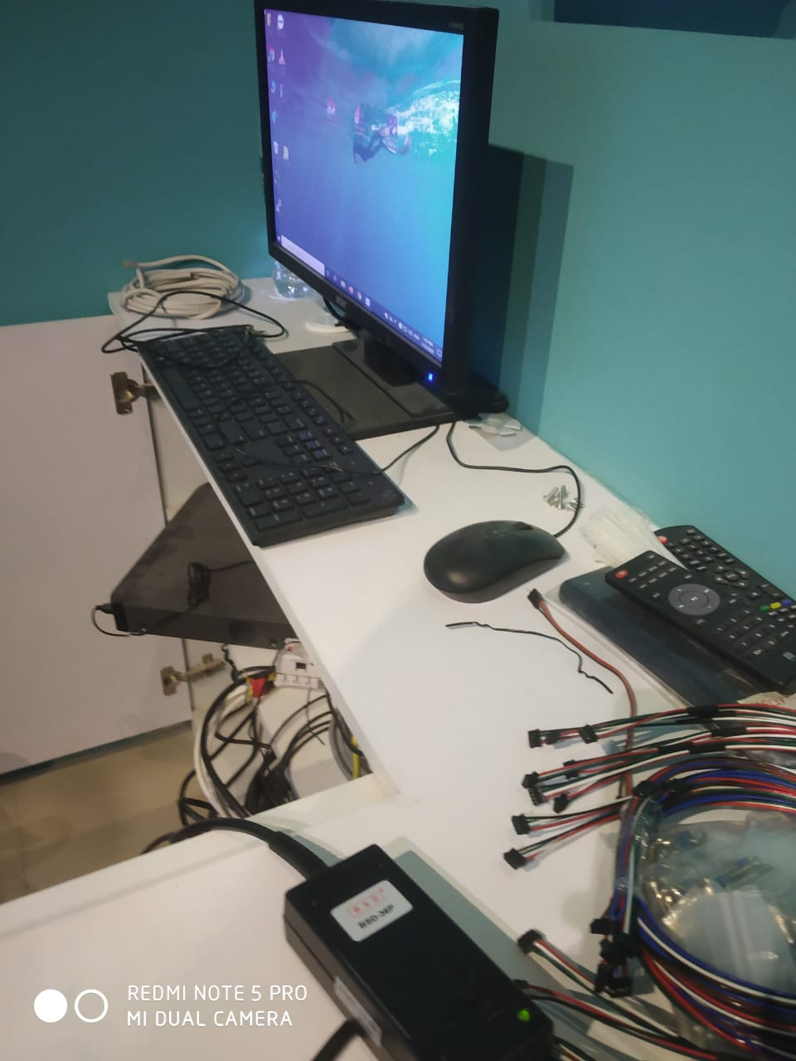

Fig 4.2.1: Personal computer

It controls the whole game by handling total access over the equipment and allows user friendly interface to incorporate the required usage to the user.It mainly consists of mouse, monitor, CPU, keyboard. It is connected to bigger TV monitor through device extension. Here we can able to display the scoreboard and briefing videos as well.

The main use of PC is to open it and start the deltastrike software and connect all the devices to the server. Then the start game post selection of particular mode among available several modes are processed.

**4.3 Shields And Guns**

As we enter deep into the game we need to use certain things to fulfill the requirements of game apart from server connections like shields atta- ched with guns.

Here the shields need to be worn over the body and to be entered inside the arena. Once we enter the arena the devices will be connected with the server post start of game. Then the sounds along with lights also gets started.

Shields are pre attached with sensors to reflect the score once it was hit by the laser beam from the opponent’s gun. Those sensors were attached at four different places each sensor with different score points. The laser beam from gun it won’t hurt the human body including all parts of the body. The persons with different scoring will be given different names like trigger happy, most accurate and super hero.

Here trigger happy player indicates that he was keep on shooting the gun against the opponents and there was no proper aiming at all. Secondly most accurate indicates he was aiming perfectly at the opponent teammates and superhero is the one with highest score at the end of the game.

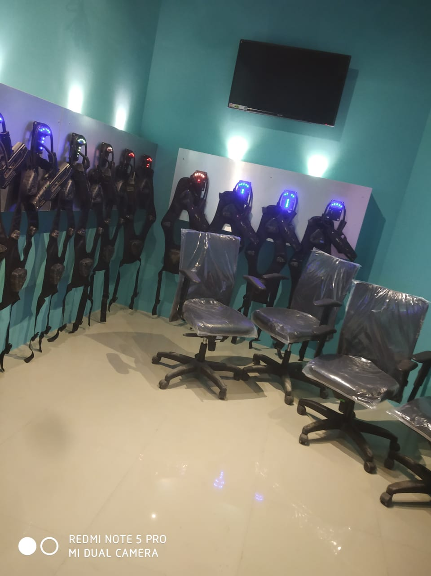

Fig 4.3.1: shields connected with guns

The issues in connection of shields with server causes error notification in the system. While rest- arting the system makes it perfect.

**4.4 Inner view of a Gun**

Everything inside the gun is connected to a single printed circuit board(PCB). All the sensors and trigger including lcd display over the gun are combinely connected to this PCB45A.The connections inside the gun consists of very limited circuitry as indicated below.

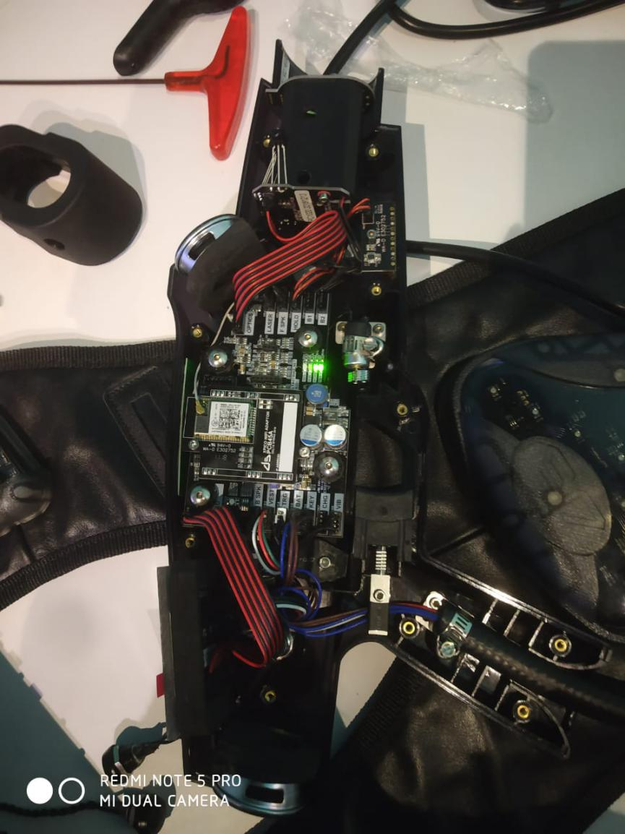

Fig 4.4.1: inside circuitry of gun

**4.5 Screw Driver**

Issues in the connections of gun inside the circuit board need to be fix by unscrewing using an screw driver machine. It has different speed levels and a control knob. Screws can be exactly driven within a few seconds.

The screws can be any width and depth based on the size the driver bit can be changed and gets power from AC supply.

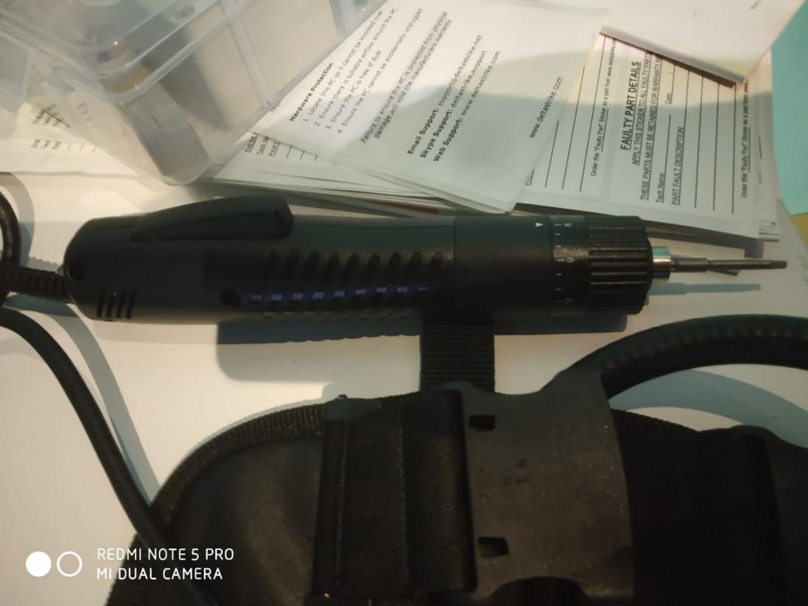

Fig 4.5.1: Screw Driver

**CHAPTER 5**

SOFTWARE DESCRIPTION

The software used in the escape room game is HOUDINI MC. It is an well and good advanced software. It consists of all the features which are pre defined. Once the game starts the timing board will be turned on on a big screen which needs to be shifted to the extended screen.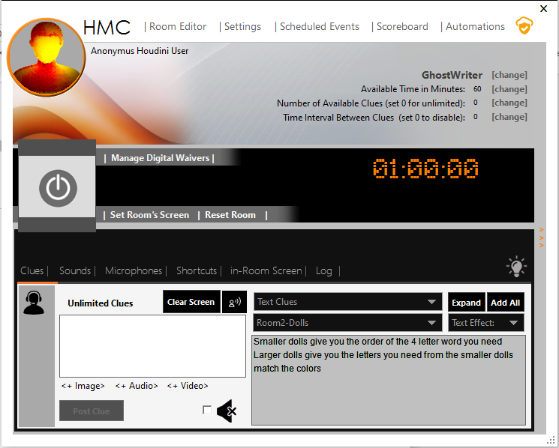

Fig 5.1: Houdini MC home screen

ROOM EDITOR: Here all the clues and puzzles will be saved in detail previously.

SETTINGS: It consists of all the setting feature to set all the sounds and themes.

SCHEDULED EVENTS: Here all the things that to be executed at particular times will be mentioned prior while the time of software installation.

SCOREBOARD: It stores the info regarding the completion time and count of clues took by the players. Based on this both the things the score points will be calculated.

AUTOMATIONS: It stores the raspberry pi relays that are used in the puzzles fixed to doors and locks.

POWER BUTTON: Once the button is clicked the game gets started and count down timer of one hour starts running.

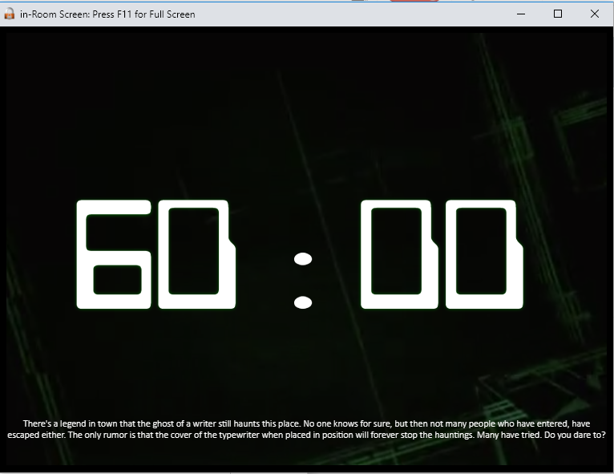

Fig 5.2: Timing screen

OPERATOER CONSOLE: It is an blank window available to type the clues manually apart from those predefined clues and after typing pressing

on post clue sends data to the screen inside the room.

**CHAPTER 6**

CONCLUSION

Thus, the project operations management enhances one’s soft skills like public speaking skills, team leading skills, proper communication ability, resistivity towards stage fear etc., It also helps in working under well and good corporate environment and provides opportunity to meet different types of people day by day.

It enhances knowing all the steps in building an start-up career in future and gives knowledge regarding publishing and advertising our newly developed product. It drives our life in a new rather than towards technical burden. In the end we can conclude that it provides a good development in one’s personality development and intrapersonal skills enhancement.